Deerwalk Institute Of Technology
Database Administration

Lab:

Submitted By: Submitted To:
Name: Sagar Giri Narayan Chalise
Roll No. 205

Date:

Import Export Utility

The Export and Import utilities provide a simple way for us to transfer data objects between Oracle databases, even if they reside on platforms with different hardware and software configurations. When we run Export against an Oracle database, objects (such as tables) are extracted, followed by their related objects (such as indexes, comments, and grants), if any. The extracted data is written to an export dump file. The Import utility reads the object definitions and table data from the dump file.

To export a oracle dump file, first we need to create a directory in the system disk memory.
Executing CREATE DIRECTORY <dir_name> as ‘<location>’; creates a physical directory.
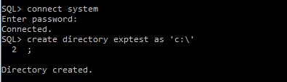

Then, a table is created, operations are performed in the existing database and are commited.
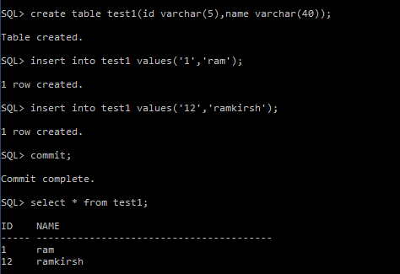

Now, to export objects, EXPD command is executed.

> EXPD <system_username>/<system_pass> DIRECTORY=<dir_name> TABLES=<table_to_export> DUMPFILE=<filename.dump>

This creates a dump file in the given directory.

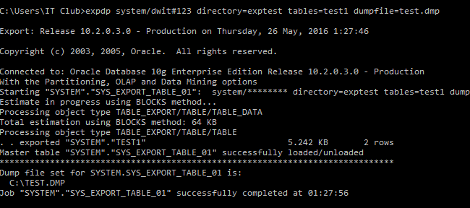

Importing a object:

We import and load the objects from dump file by using IMPD command. To verify that the import command is working, we first drop the existing table from the database.

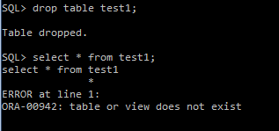

Now, we import the dump file using IMPD command.

> IMPD <system_username>/<system_pass> DIRECTORY=<dir_name> TABLES=<table_to_export> DUMPFILE=<filename.dump>

To verify that the import has worked correctly, we view the data using SELECT command.

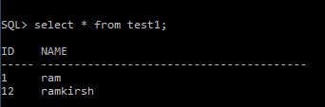

The backup dump file is created in the directory as:
